OData - Media File Handling
Structure Creation
Create a Table for the ODATA Entity to save the file udaipur by following the below.
Go to the TCODE SE11->Database Tables->Click on Create Button
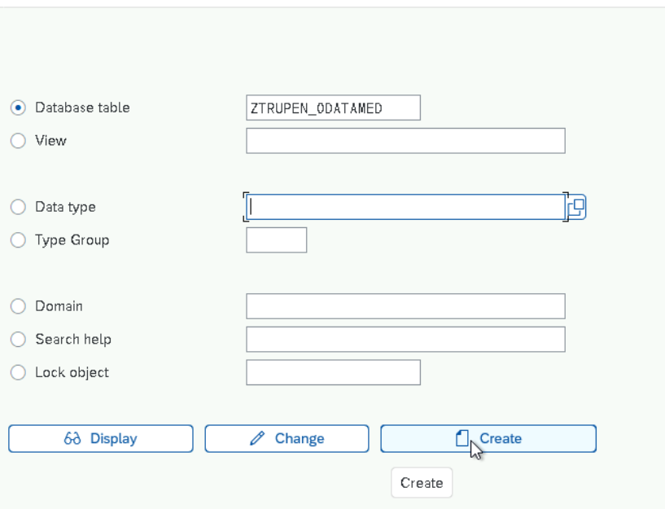
Click Enter now.
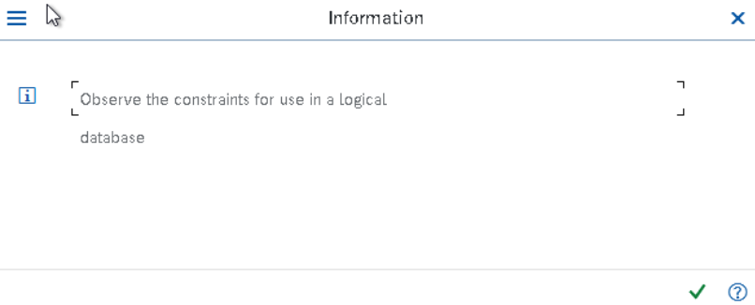
Maintain the Delivery Class as A and Table view editing as Display/Maintenance Allowed
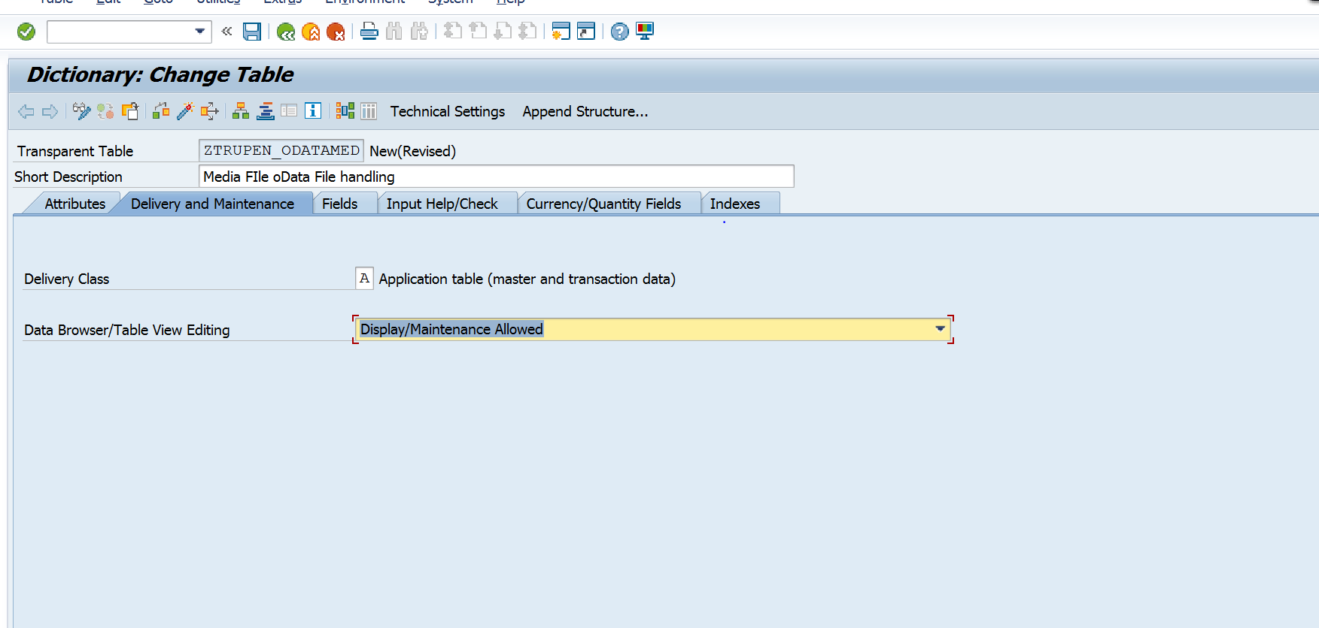
Add the Below Fields in to the Table and click on save and activate the table.
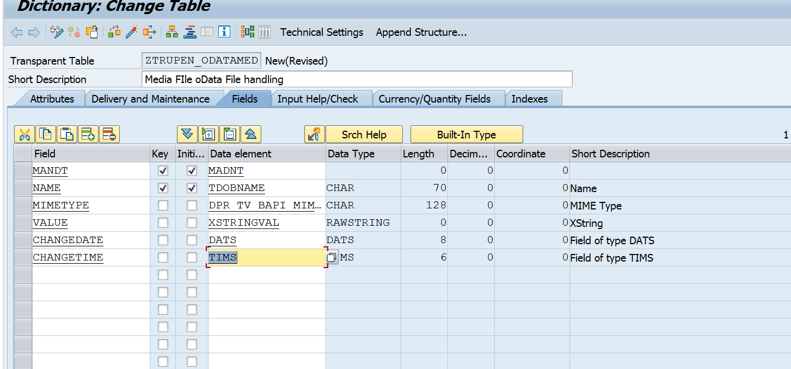
Create the Gateway Client through the Transaction SEGW.
Click on Create Project Button
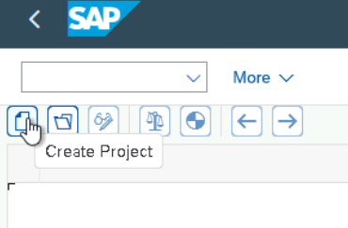
Provide the Project Name, Description and the Package Name. Click on Enter to Create the Project.
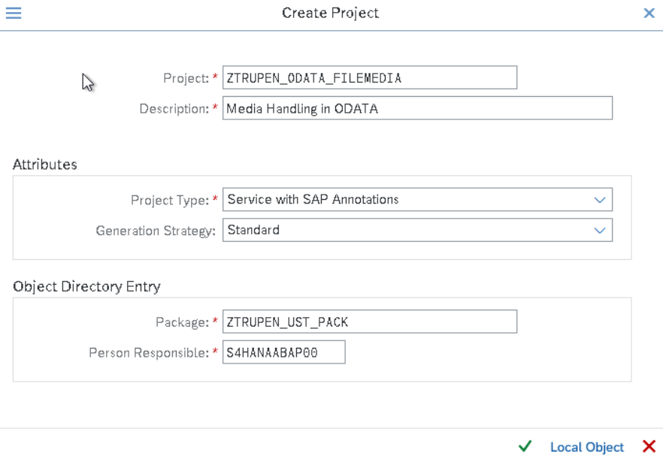
Place the Cursor on the Data Model and Right Click->Click on Import->DDIC Structure to create the Entity type and Entity sets.
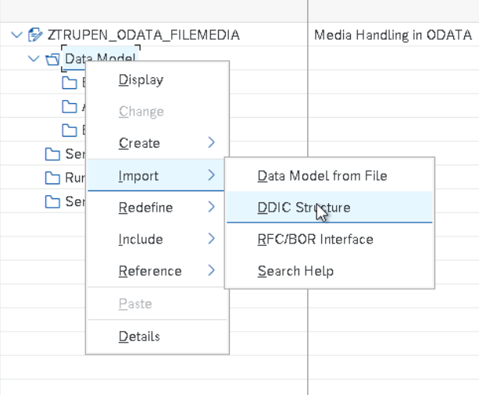
Now Provide the Name for the Entity Type, Mention the Newly Created Table ZTRUPEN_ODATAMED to the ABAP Structure and Check the Create Default Entity Set and Click on Next Button.
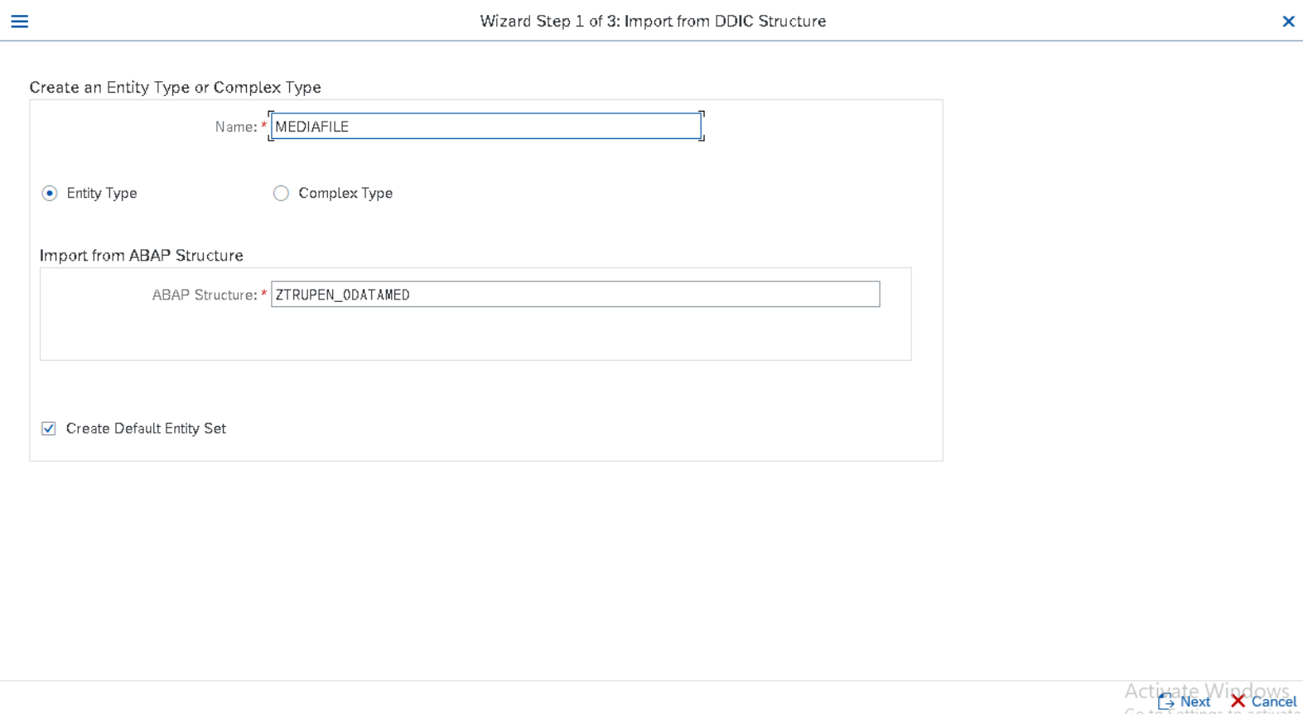
Select the Required fields for the Entity Structure from the list of fields selected from the Table and click in Next.
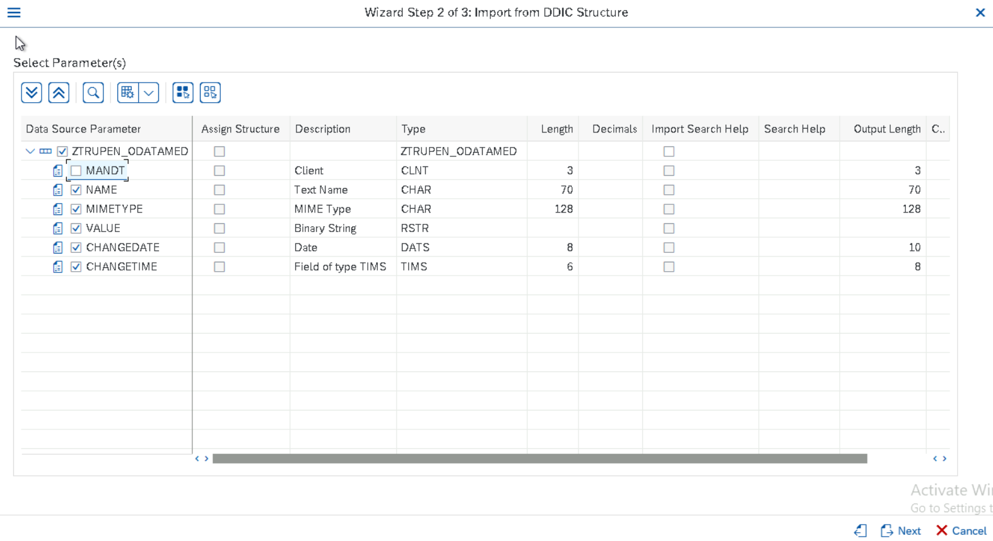
Choose the Key Fields for the Entity type and Click on Finish button.
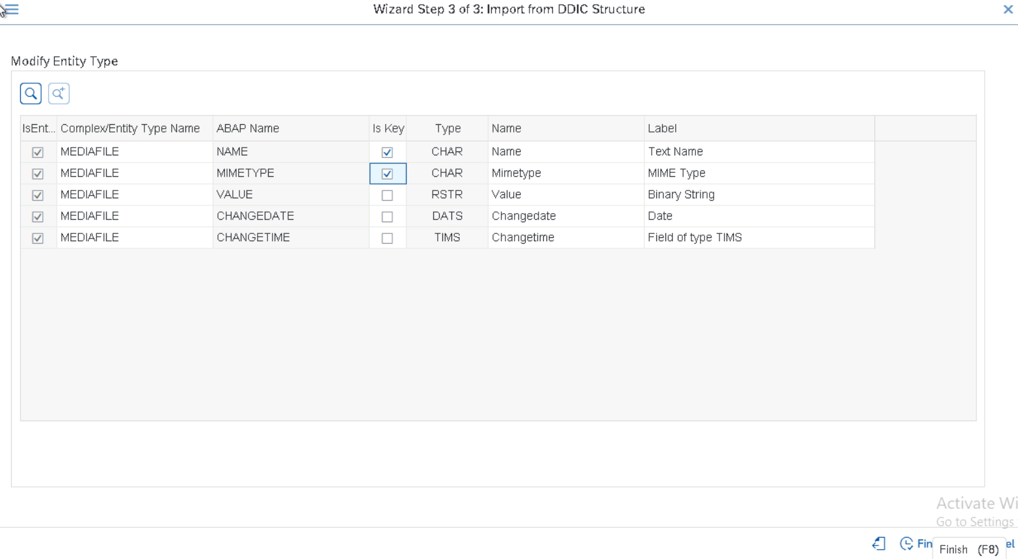
Now the Below Screen will appear and we can see the list of fields created as a properties for the Etity types and the Corresponding Sets also created.
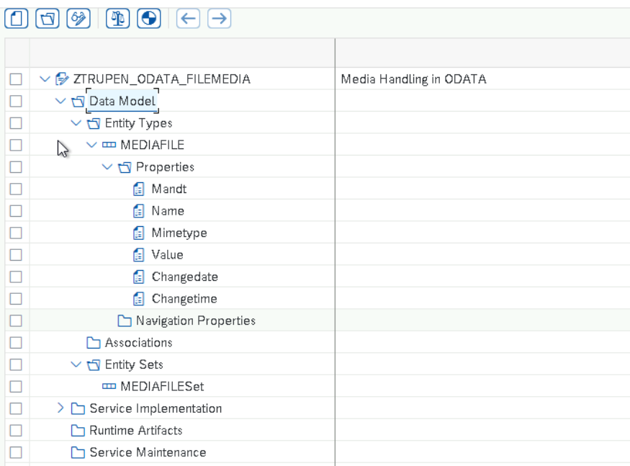
Now Doble Click on newly created Entity types MEDIAFILE and check the Media field to indicate that this entity is used for handling the Image.
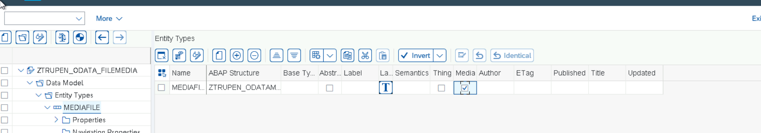
Now Click on Generate Run time Objects to generate the Classes for the ODATA Object.
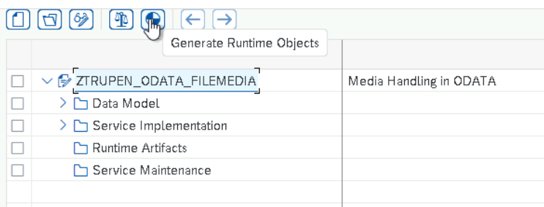
Enter the TR Number for the Service Builder and Click on Enter.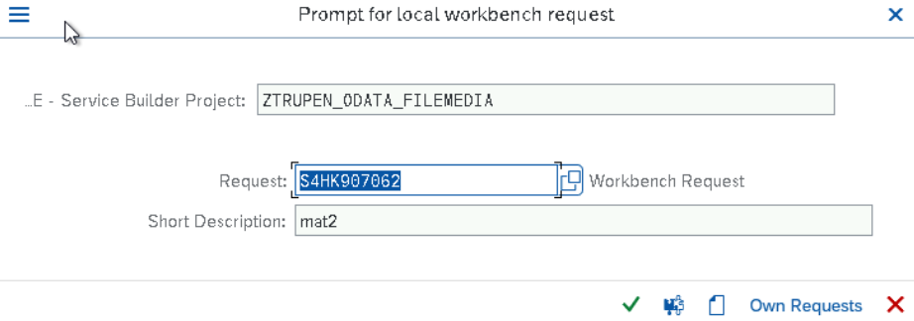
System proposes the Class name, Model Name and Service name here by default and we can modify it to the Customer Namespace if required. Now Click on Enter to complete the Runtime Object Generation.
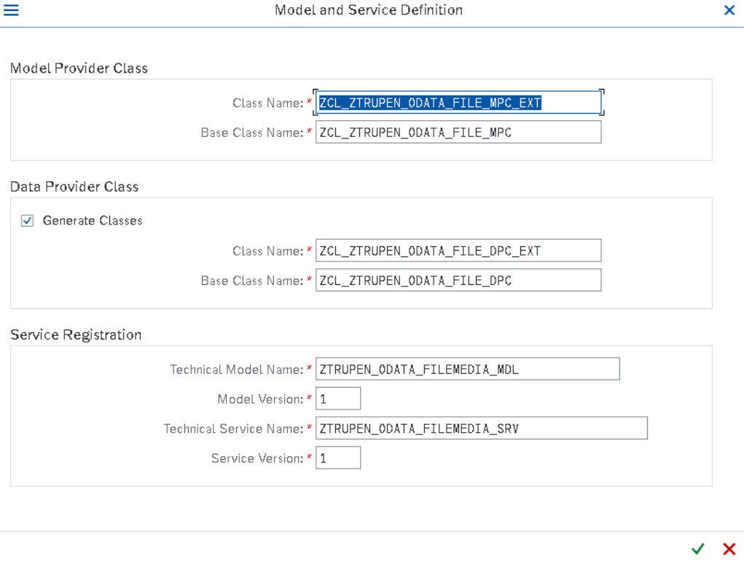
Now Enter the Package Name and Transport to save the generated Run time Objects.

Now we could see the Below Screen which shows the Messages along with the Class names, Model name and service name generated for the ODATA Service.
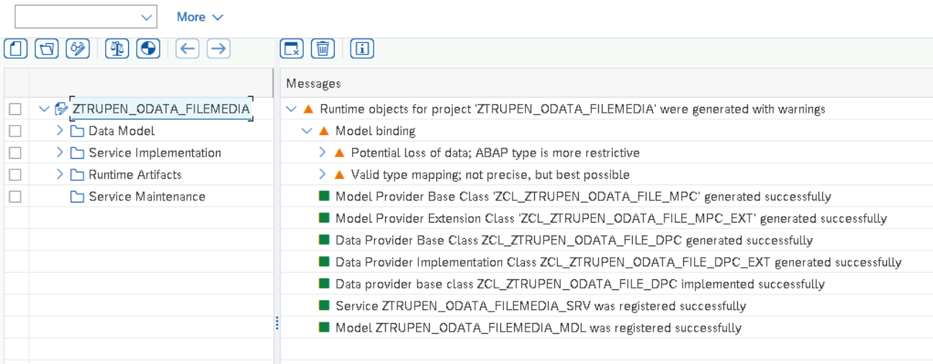
MODEL Provider Class Enhancement
Now Double click on Runtime Objects and Double click on Model provider extension class ends with _MPC_EXT to redefine the Define Method as we need to Enhance the Property for the Entity.
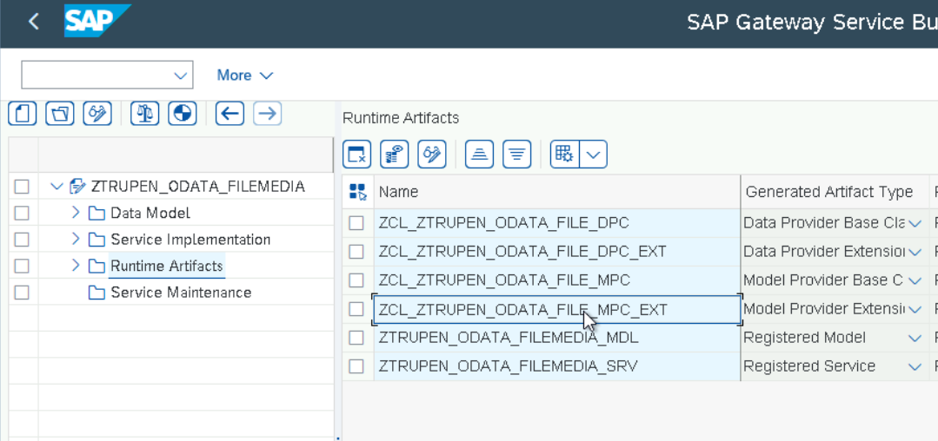
Now the Below Screen will be appeared and Expand the Methods -> Inherited Methods -> /IWBEP/IF_MGW_MED_LOAD -> Right Click on the Method DEFINE->Click on Redefine.
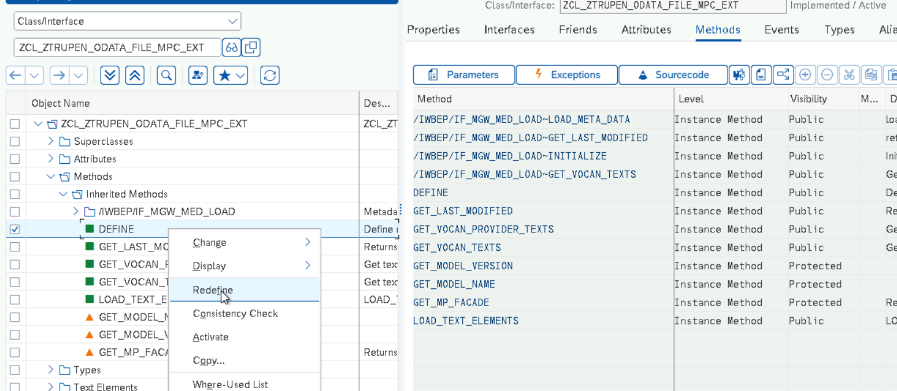
Now Implement the Define Method with the Below Code and activate. Go back to Gateway service builder.
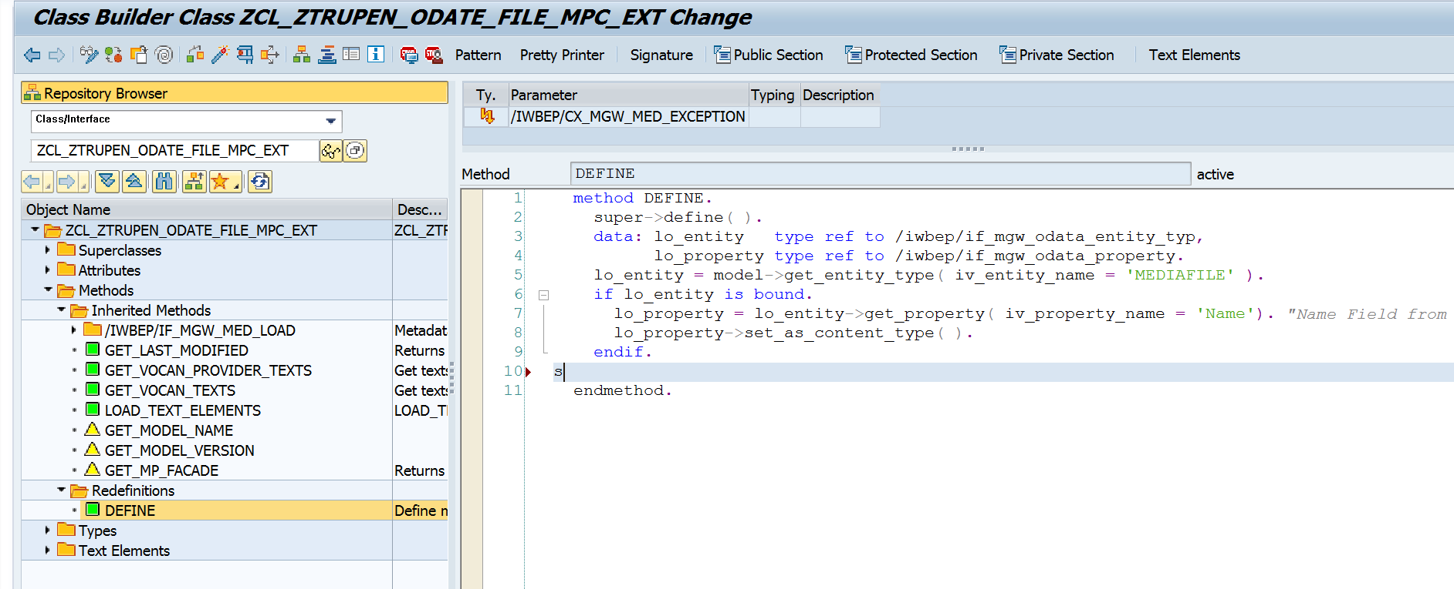
Code Snippet:
method define.
super->define( ).
data: lo_entity type ref to /iwbep/if_mgw_odata_entity_typ,
lo_property type ref to /iwbep/if_mgw_odata_property.
lo_entity = model->get_entity_type( iv_entity_name = 'MEDIAFILE' ).
if lo_entity is bound.
lo_property = lo_entity->get_property( iv_property_name = 'Name'). "Name Field from the Table
lo_property->set_as_content_type( ).
endif.
endmethod.
Data Provider Class Enhancement
Enhance the Data provide class to implement the Stream methods for handling Media Files
Go to Gateway Service Builder –>Double Click on Runtime Artifacts->Double click on the Data Provider class extension Ends with _DPC_EXT.
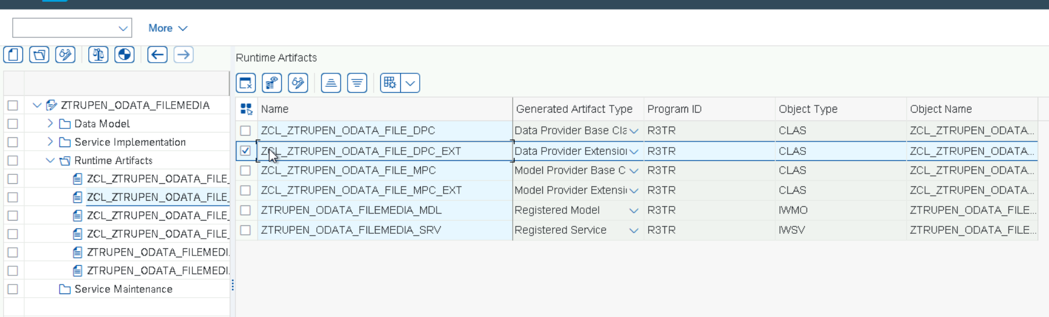
Now the Below Screen Will appear and Expand the Methods -> Inherited Methods -> /IWBEP/IF_MGW_APPL_SRV_RUNTIME -> Right Click on CREATE_STREAM -> click on Redefine.
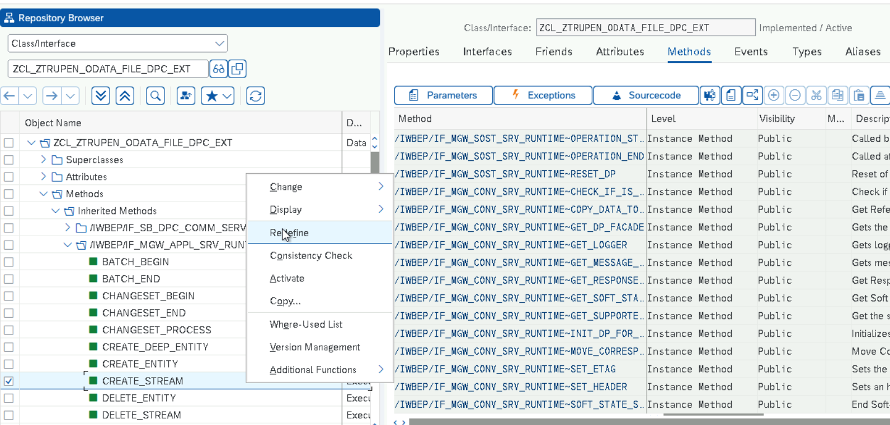
Now we can redefine the code and write our own logic to save the Image content to the Table.
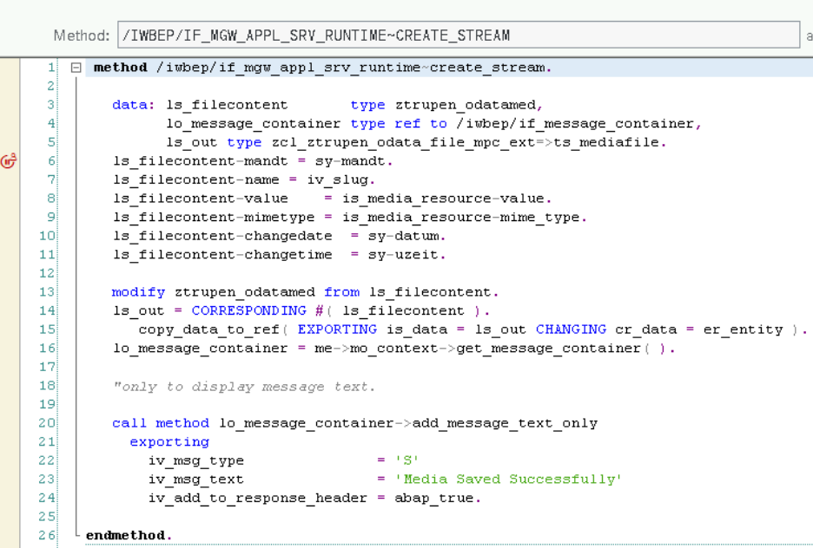
Similarly Redefine the Methods UPDATE_STREAM to modify the Image, DELETE_STREAM to delete the Image and GET_STREAM to retrieve the Image from the inherited methods/IWBEP/IF_MGW_APPL_SRV_RUNTIME and Refine the Method MEDIA_FILESET_GET_ENTITYSET from the inherited method /IWBEP/IF_MGW_SOST_SRV_RUNTIME.
Code Snippets
CREATE_STREAM
method /iwbep/if_mgw_appl_srv_runtime~create_stream.

data: ls_filecontent type ztrupen_odatamed,
lo_message_container type ref to /iwbep/if_message_container,
ls_out type zcl_ztrupen_odata_file_mpc_ext=>ts_mediafile.
ls_filecontent-mandt = sy-mandt.
ls_filecontent-name = iv_slug.
ls_filecontent-value = is_media_resource-value.
ls_filecontent-mimetype = is_media_resource-mime_type.
ls_filecontent-changedate = sy-datum.
ls_filecontent-changetime = sy-uzeit.

modify ztrupen_odatamed from ls_filecontent.
ls_out = CORRESPONDING #( ls_filecontent ).
copy_data_to_ref( EXPORTING is_data = ls_out CHANGING cr_data = er_entity ).
lo_message_container = me->mo_context->get_message_container( ).

"only to display message text.

call method lo_message_container->add_message_text_only
exporting
iv_msg_type = 'S'
iv_msg_text = 'Media Saved Successfully'
iv_add_to_response_header = abap_true.

endmethod.
DELETE_STREAM
method /iwbep/if_mgw_appl_srv_runtime~delete_stream.
data: ls_filecontent type ztrupen_odatamed,
lv_filename type char30,
lo_message_container type ref to /iwbep/if_message_container.
field-symbols:<fs_key> type /iwbep/s_mgw_name_value_pair.
read table it_key_tab assigning <fs_key> WITH KEY name = 'Name'.
if <fs_key> is assigned.
lv_filename = <fs_key>-value.
endif.
select single * from ztrupen_odatamed into ls_filecontent where name = lv_filename.
if sy-subrc eq 0.
delete ztrupen_odatamed from ls_filecontent.
endif.

lo_message_container = me->mo_context->get_message_container( ).
"only to display message text.
call method lo_message_container->add_message_text_only
exporting
iv_msg_type = 'S'
iv_msg_text = 'Image Deleted Successfully'
iv_add_to_response_header = abap_true.
endmethod.
UPDATE_STREAM
method /IWBEP/IF_MGW_APPL_SRV_RUNTIME~UPDATE_STREAM.
data: ls_filecontent type ztrupen_odatamed,
lv_filename type char30,
lo_message_container type ref to /iwbep/if_message_container.
field-symbols:<fs_key> type /iwbep/s_mgw_name_value_pair.
read table it_key_tab assigning <fs_key> WITH KEY name = 'Name'.
if <fs_key> is assigned.
lv_filename = <fs_key>-value.
endif.
ls_filecontent-mandt = sy-mandt.
ls_filecontent-name = lv_filename.
ls_filecontent-value = is_media_resource-value.
ls_filecontent-mimetype = is_media_resource-mime_type.
ls_filecontent-changedate = sy-datum.
ls_filecontent-changetime = sy-uzeit.
modify ztrupen_odatamed from ls_filecontent.
lo_message_container = me->mo_context->get_message_container( ).
"only to display message text.
call method lo_message_container->add_message_text_only
exporting
iv_msg_type = 'S'
iv_msg_text = 'Image Changed Successfully'
iv_add_to_response_header = abap_true.
endmethod.

GET_STREAM
method /iwbep/if_mgw_appl_srv_runtime~get_stream.
data : ls_stream type ty_s_media_resource,
ls_filecontent type ztrupen_odatamed,
lv_filename type char30.
field-symbols:<fs_key> type /iwbep/s_mgw_name_value_pair.
read table it_key_tab assigning <fs_key> WITH KEY name = 'Name'.
if <fs_key> is assigned.
lv_filename = <fs_key>-value.
endif.
select single * from ztrupen_odatamed into ls_filecontent where name = lv_filename.
if sy-subrc eq 0 and ls_filecontent is not initial.
ls_stream-value = ls_filecontent-value.
ls_stream-mime_type = ls_filecontent-mimetype.
copy_data_to_ref( exporting is_data = ls_stream changing cr_data = er_stream ).
endif.
endmethod.

SERVICE Activation
Service has to be activated using the Transaction Code /IWFND/MAINT_SERVICE.
GO to TCODE /IWFND/MAINT_SERVICE -> Click on Add Service Button.
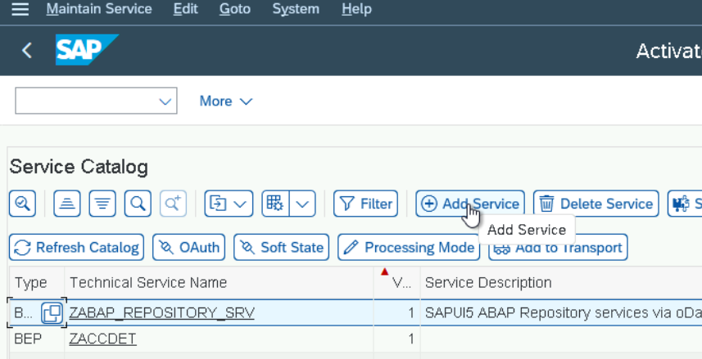
Enter the system Alias as Local and filter the technical service name created during the Runtime Generation. Now Select the Service in the Check box and Click on Add Selected Service.
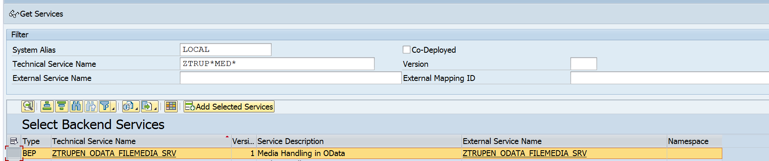
System proposes the Technical service name and technical model Name by default and enter the Package Name and Click on Enter.
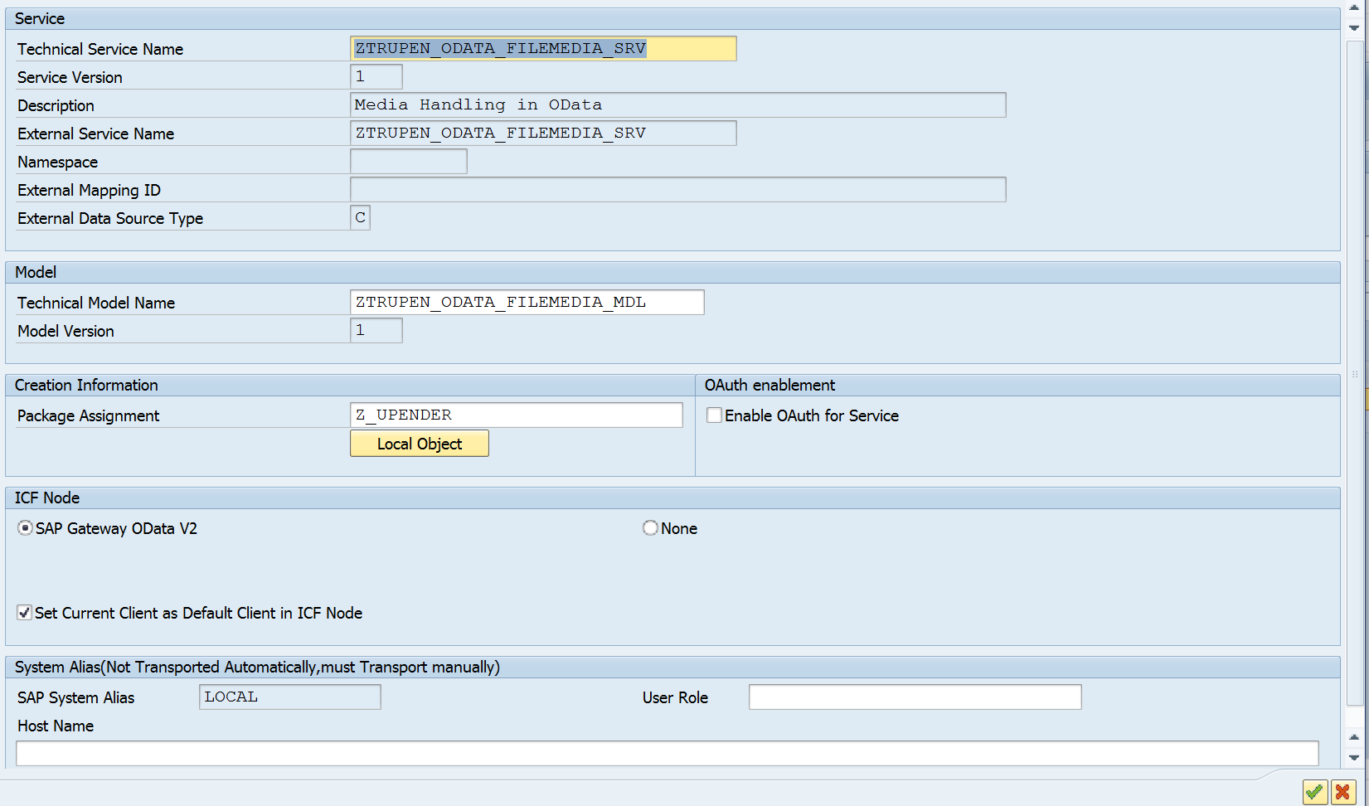
Enter the Transport for the Model Metadata and Click on Enter.
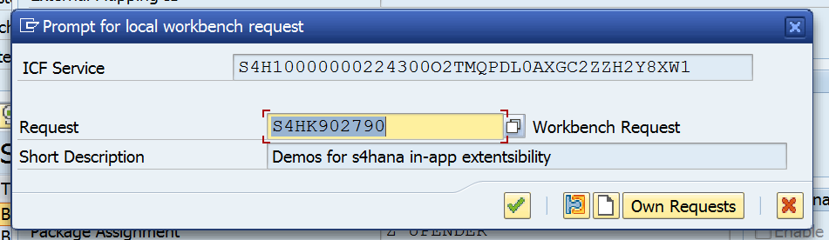
Enter the Transport for the ICF Service and Click on Enter

Now the Service is Activated and we need to configure the SICF Service by Expanding the Drop Down in ICF Node -> Click on Configure SICF .
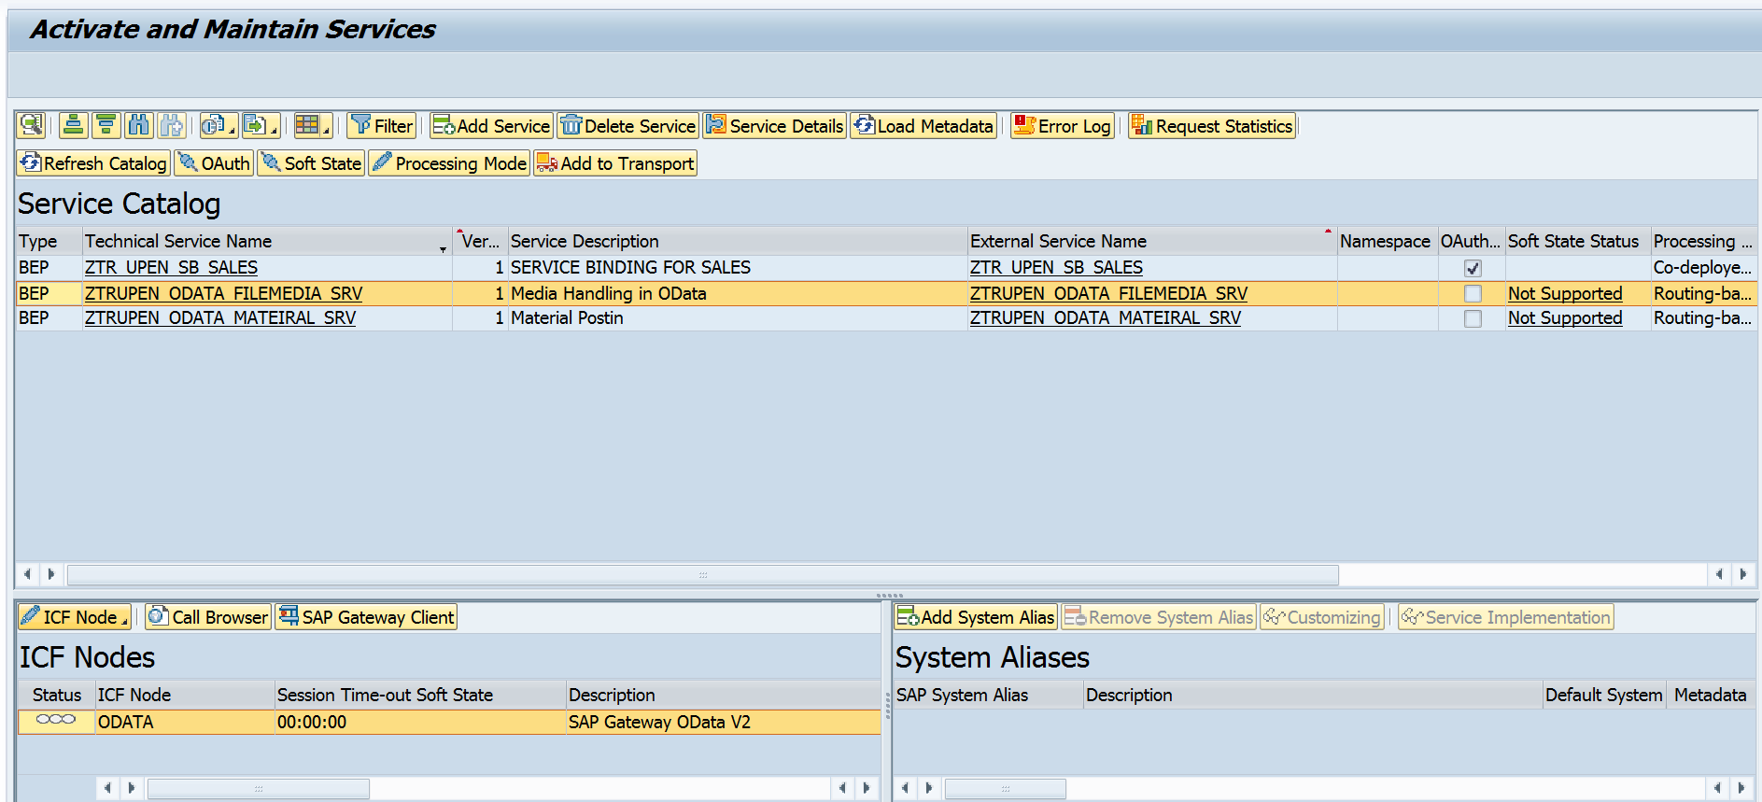
Now the Below screen will appear after clicking the Configure SICF button and double click on the Service now to check the ICF Node.
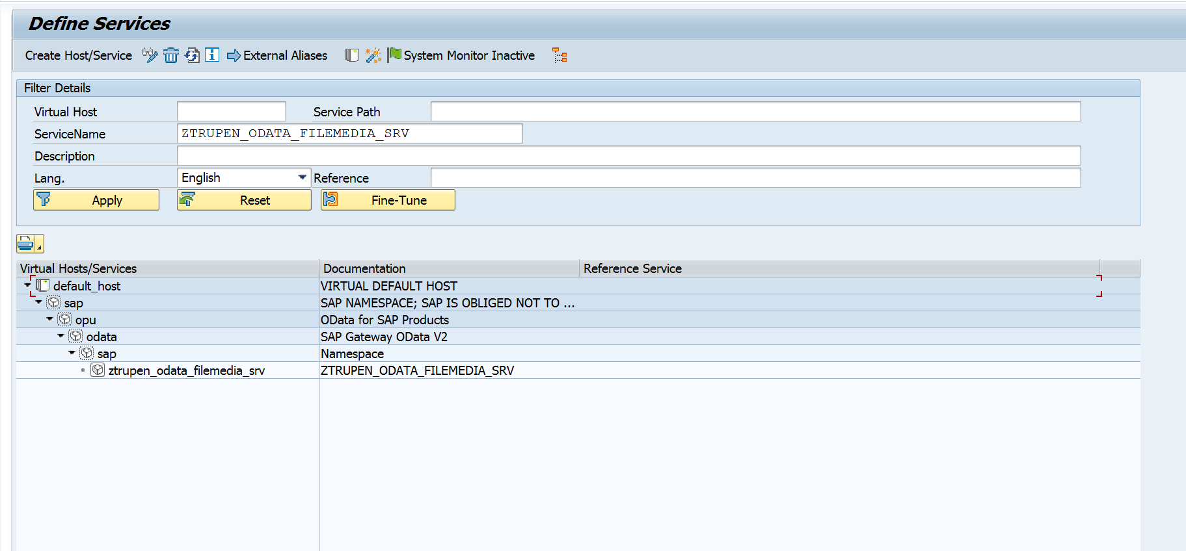
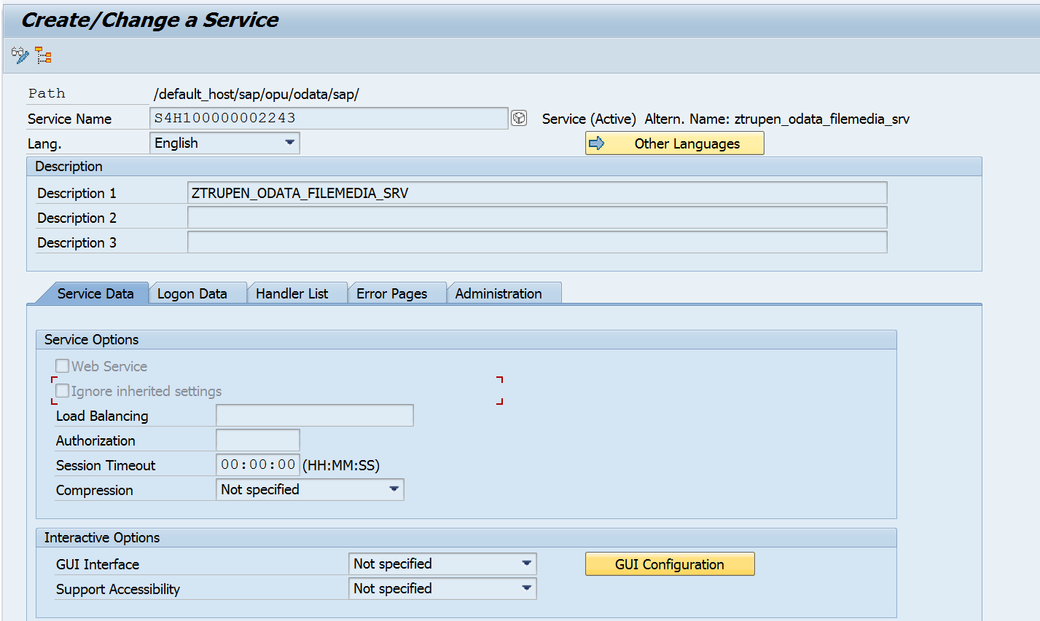
We can see the Service details now and Go in Change Mode and Click on the GUI Configuration Button in the Service Data section to add the parameter for disabling the CSRF Token Validation. (This step depends upon the system configuration and the CSRF Token Validation is enabled at the system level, we are disabling the CSRF token validation at the Service level to test the Gateway service from Gateway Client)
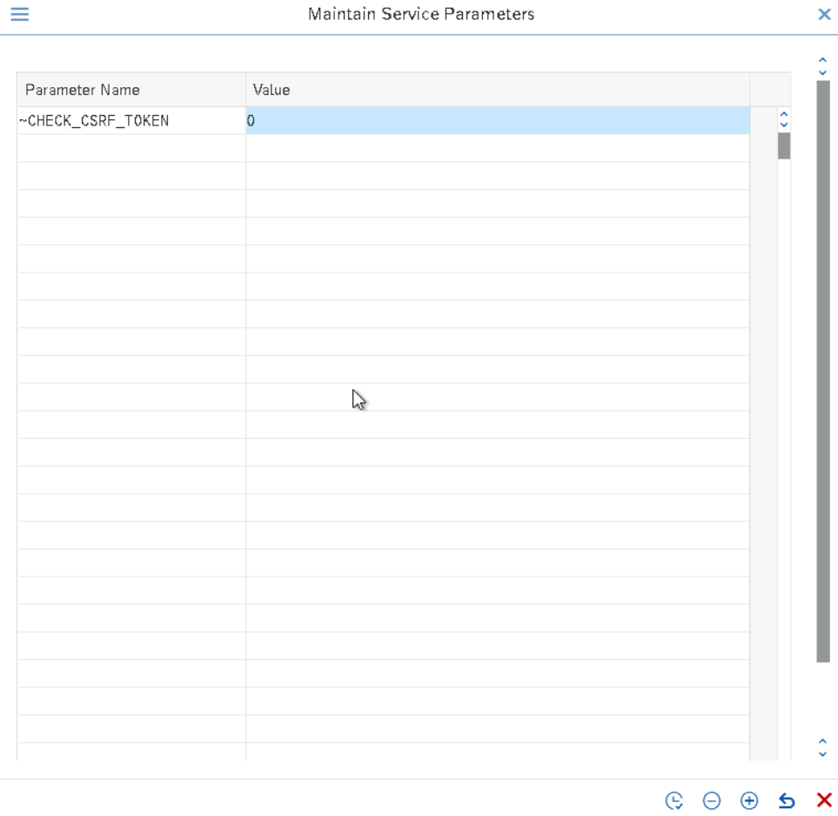
Click on Execute SAP Gateway Client button to test the Service
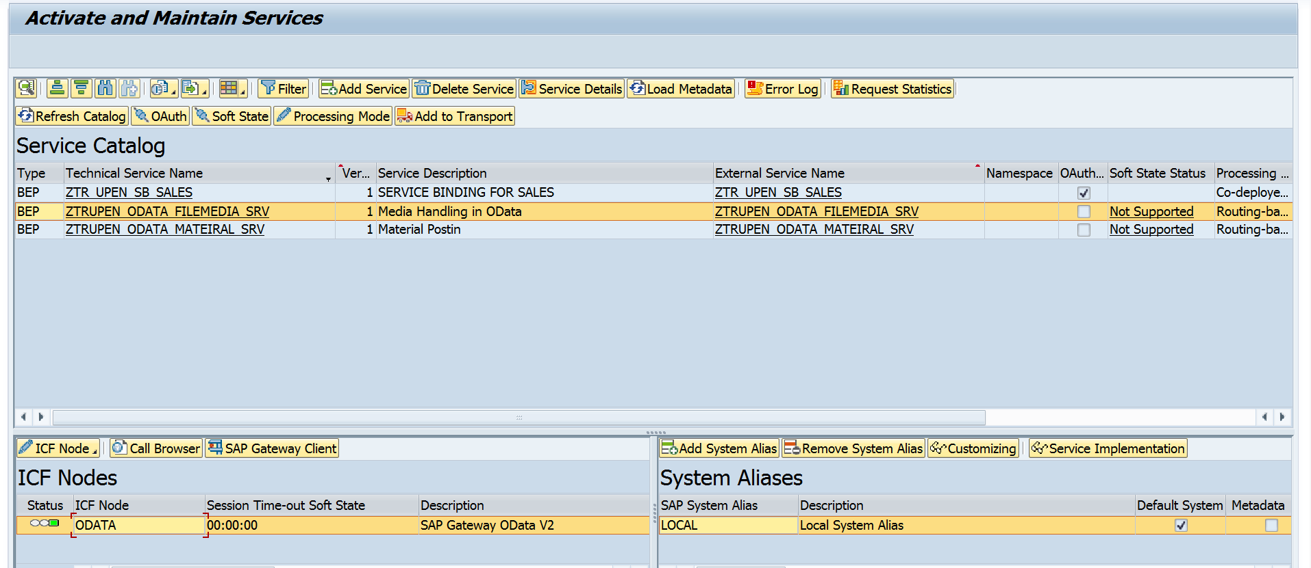
TESTING
Post – Upload Image
Choose the Entity set MEDIAFILESet on the URI
URI : http://atosfaa2.mydomain.com:50000/sap/opu/odata/sap/ZTRUPEN_ODATA_FILEMEDIA_SRV/MEDIAFILESet

Now we need to add the HTTP Parameter SLUG and its value as name of file in the Header.
Note: SLUG is the header parameter is used to pass the key field along with media type in ODATA services for attachments.
Click on Add Header
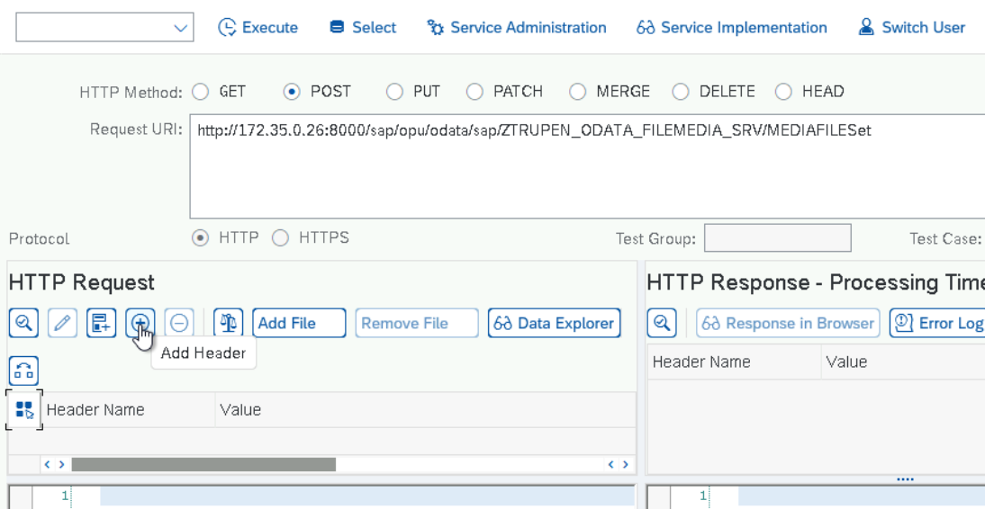
Input the HTTP Header Parameters now.
SLUG
logo
Now Click on the Add file button to add the image in to the HTTP Body.

Check the Check Box and Click on Allow.
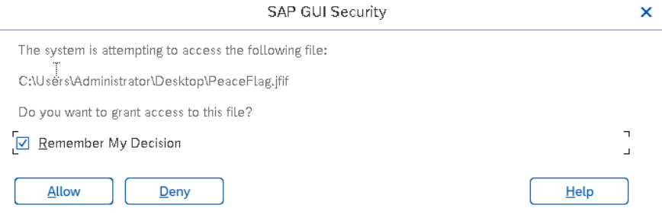
Now the Image is uploaded and the Content-Type Image/JPEG is added automatically to the HTTP header based on the Image Uploaded and Click on Execute Button to post the image.
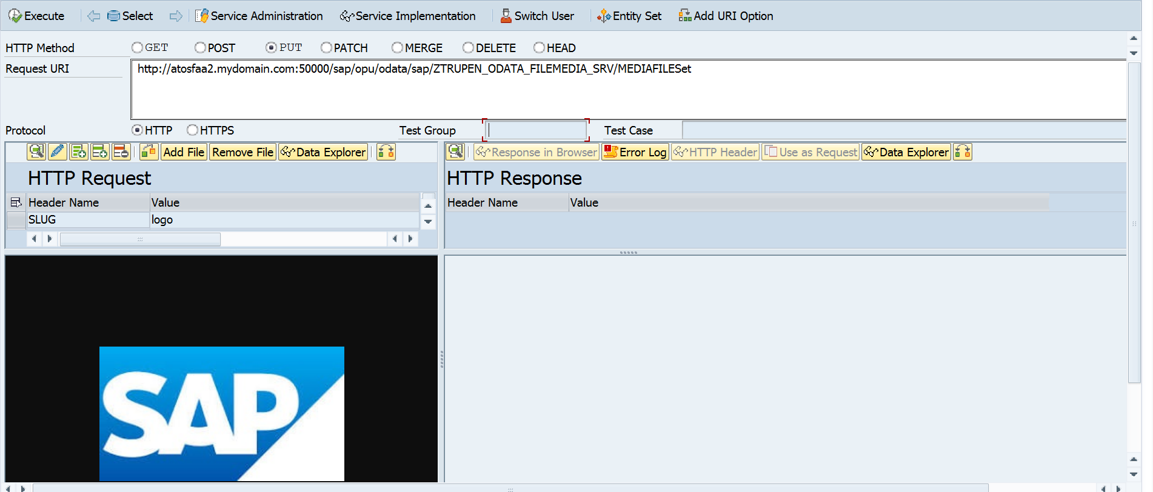
Enter the Log on Credentials to execute the URI in the Gateway Client.

Output

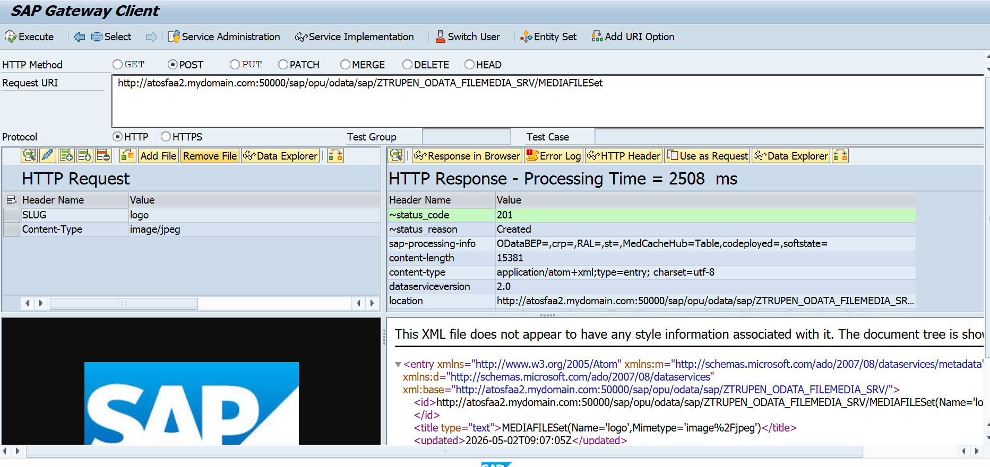
Z Table entries are added no IN SE11

Update:PUT
URI: http://atosfaa2.mydomain.com:50000/sap/opu/odata/sap/ZTRUPEN_ODATA_FILEMEDIA_SRV/MEDIAFILESet(Name='logo',Mimetype='image%2Fjpeg')/$value

Now Click on Add File again and choose different image.
Click on Execute button to post the image now.

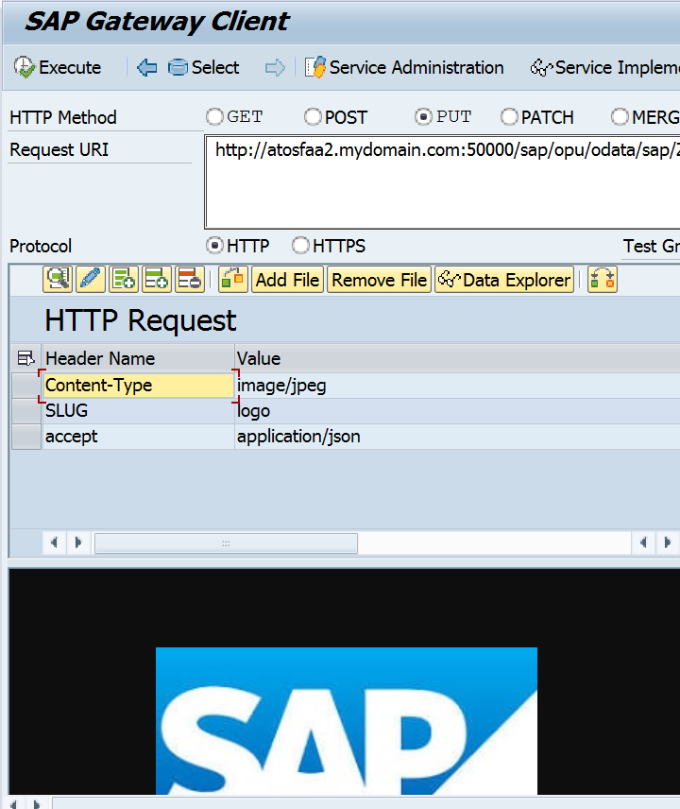
Enter the Log on Credentials to execute the URI in the Gateway Client.

Output
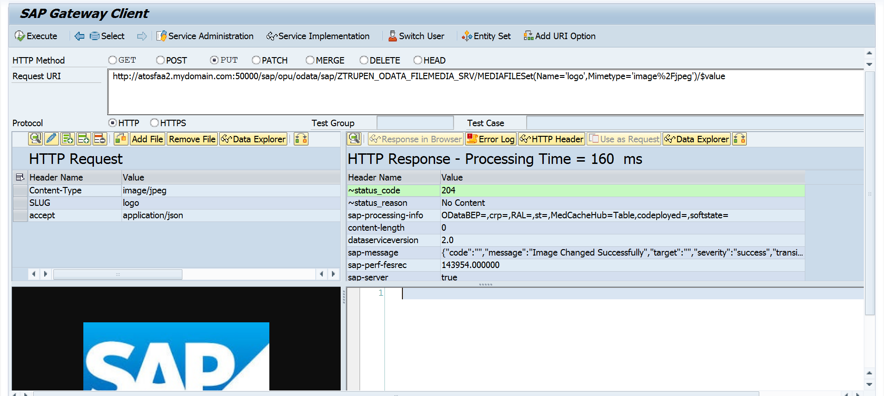

GET - retrieve the image
URI: http://atosfaa2.mydomain.com:50000/sap/opu/odata/sap/ZTRUPEN_ODATA_FILEMEDIA_SRV/MEDIAFILESet(Name='logo',Mimetype='image%2Fjpeg')/$value

Click on Execute button to retrieve the image now.

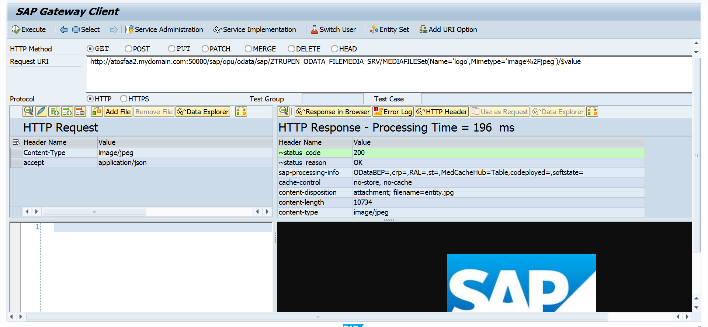
Enter the Log on Credentials to execute the URI in the Gateway Client.

Output
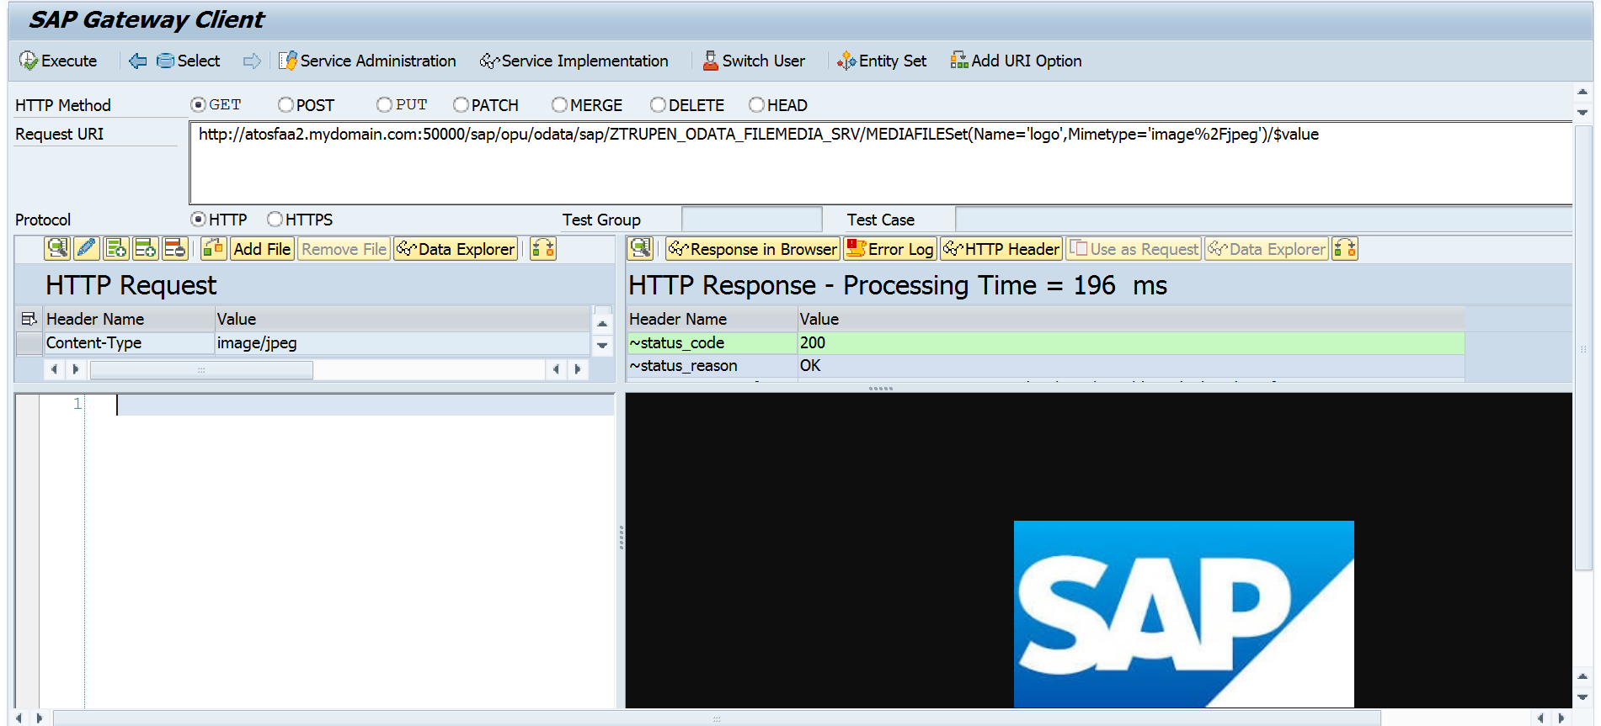

DELETE – Delete the image
URI: http://172.35.0.26:8000/sap/opu/odata/sap/ZTRUPEN_ODATA_FILEMEDIA_SRV/MEDIAFILESet(Name='Peaceflag',Mimetype='image%2Fjpeg')

Click on Execute button
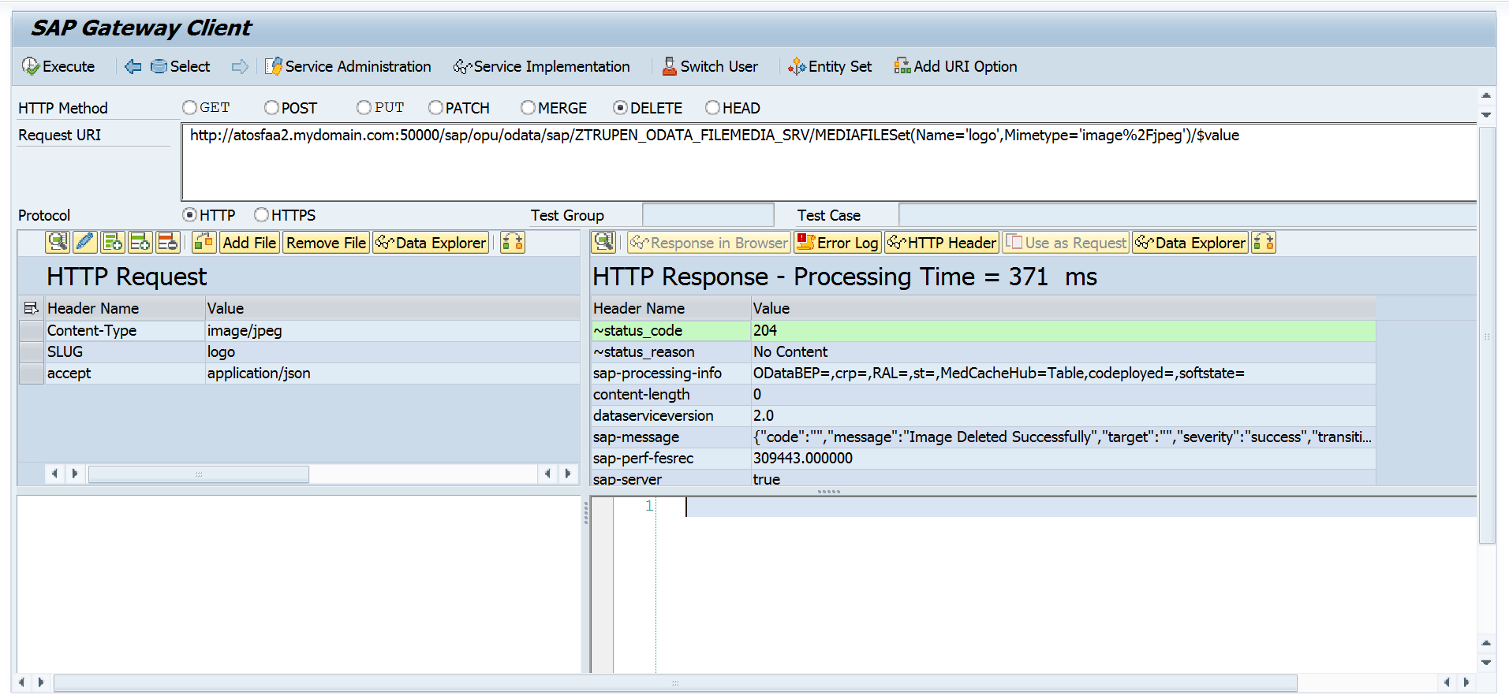
Enter the Log on Credentials to execute the URI in the Gateway Client.

OUTPUT
Image Deleted successfully.


